# Usability Engineering

# **Main Objective of the assessment**

#### You will conduct a usability engineering task around an application or device developed as a group project and written up in the form of a report. This assessment is intended to examine all of the cs2003 learning outcomes, as specified in the Learning Outcomes and Marking Criteria section below.

You will conduct a usability engineering task around an application or device developed as a group project and written up in the form of a report. This assessment is intended to examine all of the cs2003 learning outcomes, as specified in the Learning Outcomes and Marking Criteria section below.

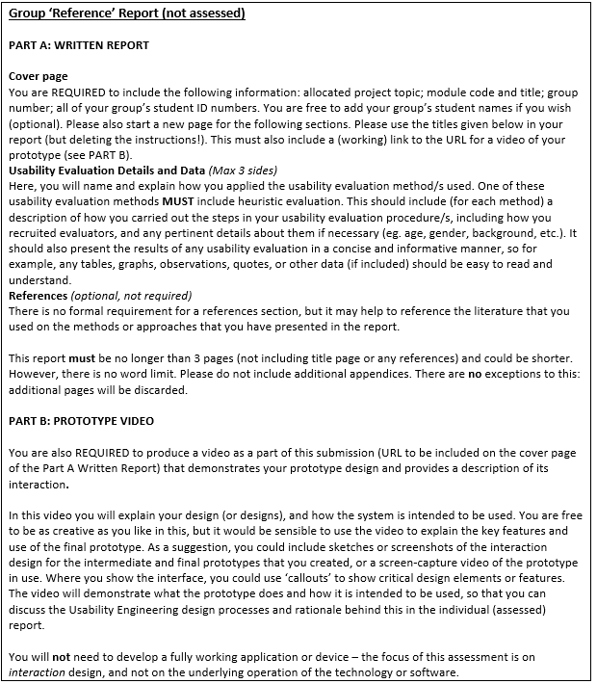

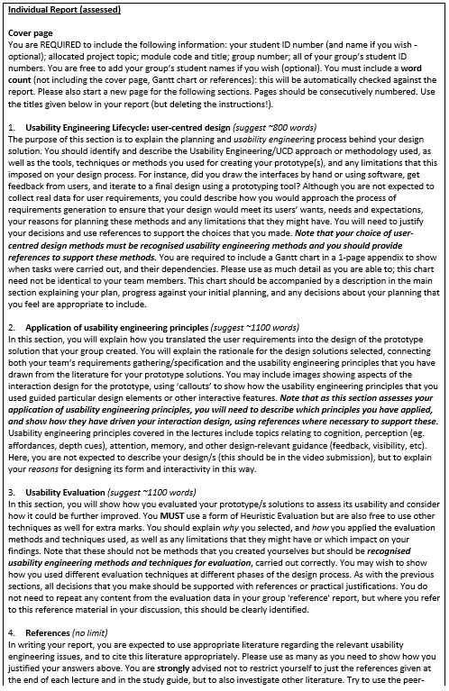

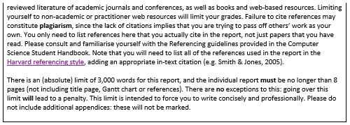

### Tasks

1. Design (GUI Sketch) - Anthony ASSIGNED
2. GUI Design (Comp Copy) - Pruthvi ASSIGNED
3. Usability Methodology - Anas ASSIGNED
4. Use Cases - Franco ASSIGNED
5. Questionnaire - Felipe ASSIGNED
6. Requirements Specification - Romi ASSIGNED
7. Report Requirements Analysis - Camron ASSIGNED

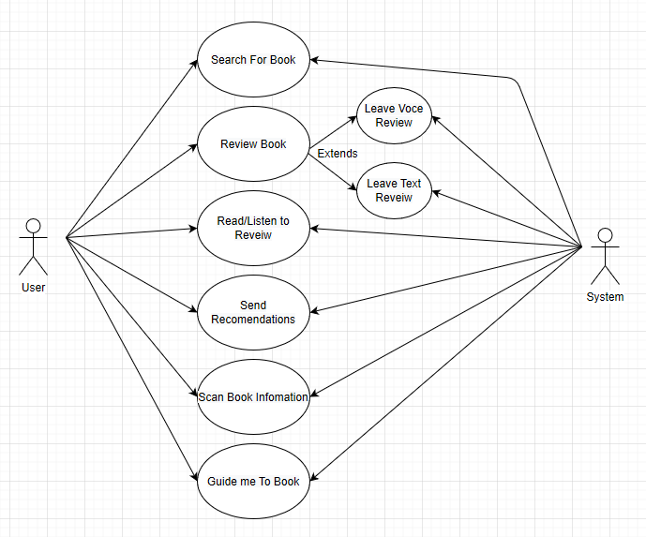

### Tasks

1. Design (GUI Sketch) - Anthony COMPLETE (Pending Review)
2. GUI Design (Comp Copy) - Pruthvi ASSIGNED
3. Usability Methodology - Anas ASSIGNED
4. Use Cases - Franco COMPLETE (Pending Review)
5. Questionnaire - Felipe COMPLETE (Pending Review)
6. Requirements Specification - Romi ASSIGNED
7. Report Requirements Analysis - Camron ASSIGNED

### Tasks 27/2/2020

1. Design (GUI Sketch) - Anthony COMPLETE
2. GUI Design (Comp Copy) - Pruthvi COMPLETE(Pending)
3. Usability Methodology - Anas COMPLETE
4. Use Cases - Franco COMPLETE(Add Descriptive Text)
5. Questionnaire - Felipe COMPLETE(Not Adequate)
6. Requirements Specification - Romi COMPLETE(Pending Improvement)
7. Report Requirements Analysis - Camron ASSIGNED(NO PROGRESS)
8. Presentation - Franco ASSIGNED

Current task status has been taken directly from github 10 minutes before the meeting any incompleteness is not excusable. If you are marken in anything other than green then you are grossly behind schedule.